
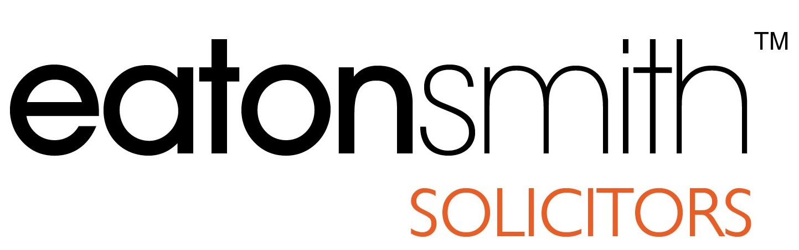




BUSINESS OF THE MONTH AWARD

Calderdale-Kirklees-Wakefield

APPLICATION FORM

Would you like to enter your company for the prestigious

Business of the Month Award?

Established in 1995, the award has been won by a diverse range of companies and businesses over that time. It doesn't matter how large or small your business or workforce, all applications are treated equally.

All winners are featured in Close-Up and the local press and are automatically entered for the Business of the Year Award.

You too could be the winner of our monthly award

– give it a try, who knows it could be you!

If you would like to enter your business, please fill in the attached form and return it, together with any additional information you wish to supply, for the attention of:-

Ian Greenwood
Eaton Smith
14 High Street, Huddersfield, HD1 2HA.
Email: iangreenwood@eatonsmith.co.uk

BUSINESS OF THE MONTH AWARD – APPLICATION FORM

Name of Company / Business

Contact Name

Tel no

Address

Nature of Business

Date / Year when Business Commenced

History of the Business (how started etc)

Marketplace in which the Business Operates

Contribution to the Region (innovation / profile etc)

Business Growth

Financial Success (growth and trends)

Your People (numbers of staff / training / development / initiatives)

Standards achieved (e.g. ISO 9000)

Other awards received (if any)

Future plans and objectives

General Information

